Rendering Test
2026-10-16
A little reference post that exercises each rendering feature in HTML, PDF (Typst) and Word. Written by Claude Opus 5.5.

1 Text
Bold, italic, strikethrough, inline code, H₂O, E = mc², and a footnote. Links to other posts use the source path: Hello World.
- Ordered item
- Another item
  - Nested bullet
  - ☐ Task list item
A block quote.

2 Math
Inline math $e^{iπ}+1=0$, and a numbered equation, referenced as Equation 1:
$$\int_{−∞}^{∞}{e^{−x^{2}}} dx=\sqrt{π} (1)$$

3 Tables
Table 1: Output formats
Format | Engine | Interactive
HTML | Pandoc | Yes
PDF | Typst | No
Word | Pandoc | No

Table 1 lists the outputs built for each post.

4 Python Graphs
Code is executed at render time [1], using NumPy [2] and Matplotlib [3]. Figure 1 shows a single plot and Figure 2 shows a multi-panel layout.
import numpy as np
import matplotlib.pyplot as plt
x = np.linspace(0, 10, 500)
plt.plot(x, np.exp(-x / 4) * np.sin(2 * x))
plt.xlabel("t")
plt.ylabel("amplitude")
plt.show()
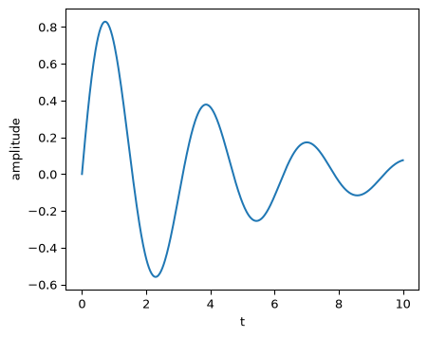
Figure 1: A damped sine wave.
rng = np.random.default_rng(0)
data = rng.normal(size=1000)
plt.hist(data, bins=30)
plt.show()
plt.scatter(data[:-1], data[1:], s=4)
plt.show()
  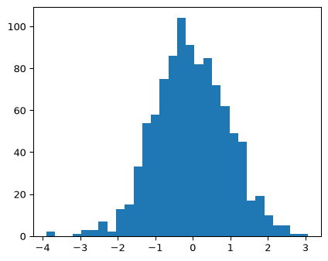
  (a) Histogram
  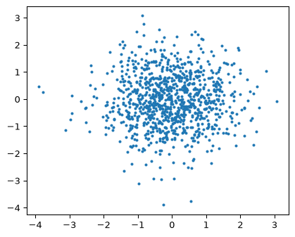
  (b) Scatter
Figure 2: Side-by-side subfigures.

5 Mermaid Diagrams
Figure 3 shows how a post is rendered.
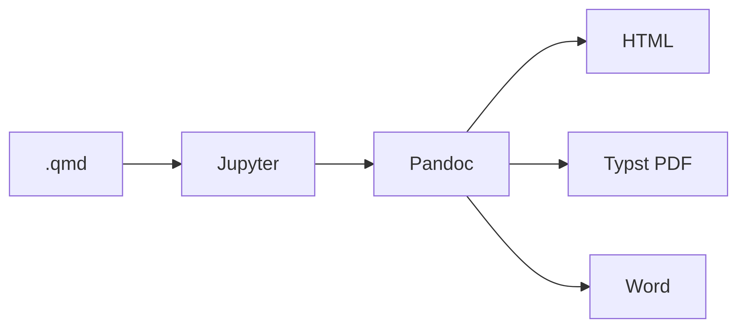
Figure 3: Quarto render pipeline.

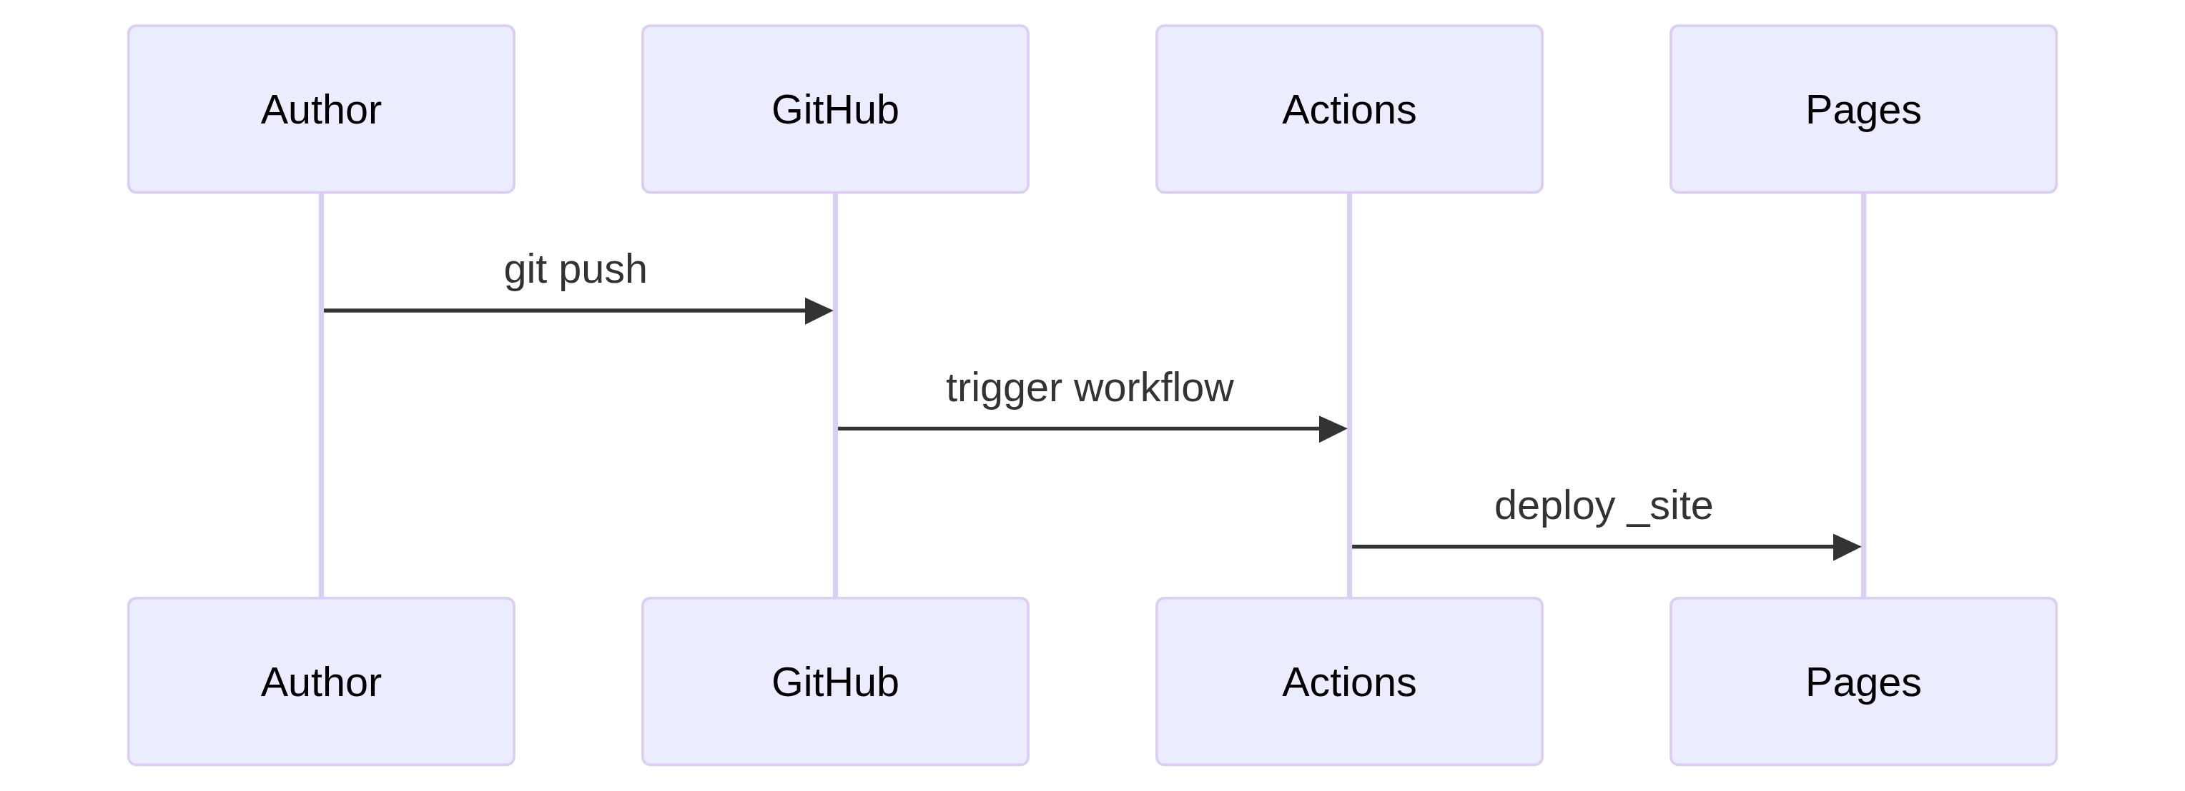

6 Callouts
 Note
A note callout.

 Custom title
A warning with a custom title.

 Collapsible tip
Collapsed by default in HTML.

7 Code Blocks
def greet(name: str) -> str:
return f"Hello, {name}!"
quarto render

8 Format-Specific Content

Tab A
Tabsets are interactive in HTML and render as sequential sections elsewhere.

Tab B
Second tab.
This paragraph only appears in PDF and Word.

References
[1] D. E. Knuth, “Literate programming,” The Computer Journal, vol. 27, no. 2, pp. 97–111, 1984, doi: 10.1093/comjnl/27.2.97.
[2] C. R. Harris, K. J. Millman, S. J. van der Walt, et al., “Array programming with NumPy,” Nature, vol. 585, pp. 357–362, 2020, doi: 10.1038/s41586-020-2649-2.
[3] J. D. Hunter, “Matplotlib: A 2D graphics environment,” Computing in Science & Engineering, vol. 9, no. 3, pp. 90–95, 2007, doi: 10.1109/MCSE.2007.55.

Footnotes render as sidenotes or endnotes depending on format.

